**Facial Recognition to catch Terrorists in**

**Public Areas**

**Abstract**

Now a days the world was fulfilling crime and terrorism in day to day life, we wasn’t control sometimes some situations. In India in 2008 Mumbai attacks was done and died number of innocent people because of there is no one wasn’t identified them at that time. Now a day’s technology is well developed to capturing criminals and their activities using CC-TV’s, but not always every time. In this application we can identify the criminals and terrorists using Open-CV face recognition software. This application was made for only who was working for Intelligence department in India. Here we can develop and application to authorised users to access terrorist records to Add,Delete,Display and Analyse (facial recognizing with cameras) them.

**1. Introduction**

**Introduction to Facial Recognition to Catch Terrorists in Public Areas**

**Introduction:**

Facial Recognition To Catch Terrorists in Public Areas is an enhanced application to Recognise criminal and Terrorist faces when they walk in front of the security cameras. Here what we are going to design. In This project we need some requirements to satisfy this application. We will discuss about these requirements later. This application have two databases one for authorised people to access this application and another for storing Terrorists data like name , country, age ,attacks like. Etc... We can store these details in this database and also could be retrieve and delete from database .here an Interesting module called Analyse module This module is used to do open the security camera to predicting faces while capturing video.

**Purpose of the project :**

So much of people dying because of Terror Attacks an in India .Of course we are using CC- cameras but probably These cameras wasn’t save people every time in real world. I wouldn’t be said this application will save one hundred percent accurate but attest we can identify to alert intelligence department and police department before crime would done. Here we will recognise the terrorists at crime spot before he wouldn’t done any crime Probably this application at least at least could work for defence departments in India.

**Problems in existed System :**

Identifying suspects in real existing system is not bad this is a good way to identify people but that holds risk some time I think so. If any police are went to identify people directly be eye sight in their areas its a risk may be anything happen with him, also we can catch him some times but sometimes probably we cannot remember all people around the world each and every one.

**Solution for these problems:**

Identifying terrorists is good thing i through so , than we could identify people smartly here my solution for this identifying terrorists in public areas with machine learning model called LBPH Face Recogniser openCV . These things are used to identify the terrorists public areas using CC-TV’s and informing higher officials who authorised users of This application. Let’s we discuss about below things.

* **Machine learning**:

Machine learning is an application of artificial intelligence (AI) that provides systems the ability to automatically learn and improve from experience without being explicitly programmed. Machine learning focuses on the development of computer programs that can access data and use it learn for themselves.

* **Open-CV:**

Open-CV (Open Source Computer Vision) is a library of programming functions mainly aimed at real-time computer vision. In simple language it is library used for Image Processing. It is mainly used to do all the operation related to Images.

This above Technology was used to create this enhanced application to solve these problems. these application will be work more efficient compared to men .This can work 24/7 without taking any rest.

**2. Requirement Analysis**

**Requirement analysis**

Requirement analysis is the process of defining the expectations of the users for an application that is to be built or modified. High quality requirements are documented. Actionable, measurable, testable. Helps to identify business opportunities, and are defined to a facilitate system design.

**Feasibility Study:**

Feasibility for this project is very low because this is an machine learning based application to recognize terrorists in public areas. Remember one thing every machine learning model is predicting features of given data .we can bring trained data of this model than it will predict data based on this. If we want more efficient predictions need more data. So that’s the reason this application is low feasibility why because availability of terrorists and suspects data is low. Another reason for low feasibility this needs always cameras it works only lighting. It needs more cost for arranging high quality cameras and we can predict faces some percentage of terrorists. Its not accurate and efficient every time but this will use as prevention from terrorists in public areas to save people.

* **Technical Feasibility**

For developing this application is very difficult because in this application is working with **sqlite3** database its fine but this needs more data every time I want to predict. **Getting terrorist data not easier** they are not coming to take photos to get identify by the cops. So its going to tough every time we want to recognize faces by this software, and also this needs **lighting to identify faces.** This application designed for government authorized officials to access and get analyze the real world people and situations.

* **Economical Feasibility :**

Economically this project needs high cost compared all projects why because this application needs a super computer and get connected by the central system to access thousands of security cameras to access all at a single time this needs a central server to distribute the results to every application accessed by the authorized officers.

* **Cost Estimation Benefit Analysis :**

Ignore cost benefits for this project first because this application needs camera we talked before so that’s the reason we are facing cameras are always taking pictures also we need to change cameras for certain times every year or months, need to maintain wireless connections so we need to arrange sub stations and staff recruiting for this station and also get high speed internet connection. This estimation is very higher. This is highly secured for government for which country have threat from terrorists.

* **Operational Feasibility** :

Operational feasibility is medium for this application Sometimes why because there was cores of people in real world filtering for each and every individual from this to identify it needs more cpus and high speed data dates but this gives best results to identify terrorists in public areas. This application needs tested data if we give more data this will predict more accurate to the people by ourselves. I mean by our computers. its gives **0% RISK**. We are maximum predict terrorists before it done by people by recognizing their faces at **public areas , party meetings and events** much more this gives more stuff for finding. It gives an easier access to identification suspects in real world. We believed this would be work accurately

**Software Requirement Specifications**

**Functional Requirements**:

A functional requirement defines a function of a system or its component, where a function is described as a specification of behavior between outputs and inputs. As defined in requirements engineering, functional requirements specify particular results of a system

1. **Login :**

* **Input:** This is an primary module, you are verified by authorized **Employee ID** and **password**. If doesn’t exist. You can create one by clicking new registration button by entering valid details.
* **Output:** If **Employee ID** and **Password** was correct you will be redirected to the application main window successfully.
* **Computation:** In this function application will redirect the user id and password to the employee database and check the giver user id and name is exist in officers table.
* **Storage :** It will connects to officers table in sqlite3 and fetch details existed and get details from the table and store display the name on application main screen

1. **New Account :**

**Input:** This function allows you to fill the valid details about existed intelligence department employee if the details entered stored to officers table in sqlite3 in python.

**Output:** In this function Employee ID is a primary key if doesn’t exist in the table it will shows you registration successful it will be activated in 24 hours.

**Computation:** This function checks either Employee ID is already existed or not. If existed it stores the data else it will show you error. It doesn’t stores employee data in table.

**Storage:** all of given details will be stored to officers table in sqlite3 database.

1. **Add Terrorist :**

**Input :** This function will opens a form to fill the details about particular terrorist like name,gender,age,country,attacks and his status than click submit this will redirect to the upload image module.

**Output :** This will show you a label called details stored to database please upload an image of a terrorist for future predictions.

**Computation :** The application processes the filled information and check the primary key of terrorist name if it was exist it shows you an error else its stores the data into terrorists table in sqlite3 database.

**Storage :** This will connect to sqlite3 application and stored terrorist details to terrorist table with and primary key.

1. **Upload Image :**

**Input:** This function is redirected from the add employee it will take an image of terrorist from root folder than store the information with given terrorists name into destination folder than redirected to train image module.

**Output:** This will shows image uploaded successfully and shows image train button to train terrorist images in machine learning model for future predictions.

**Computation:** It will selects an image from the file explorer and stores into root folder of an application, than label created upload completed and show button to train images.

**Storage :** This will store the image to root folder for training.

1. **Train Image:**

**Input :** This function will allows you to train images for future predictions it will redirected to OpenCV program to train images with labels in **YML** files.

**Output :** It will train images and create label with terrorist names as ids and stored with **.YML** file in root folder.

**Computation:** This will get all images from images folder and train images with individual name ids in .YML file format.

**Storage :** This application will create an YML file and stores to the root folder for future predictions.

1. **Search :**

**Input:** This is an function to get terrorist details to fetch from terrorists table in sqlite3. This function needs a terrorist name to check whether the terrorist data was exist or not.

**Output :** This will gives and output of terrorist name,age,gender,country,attacks and about means his status only if exist name else it show doesn’t exit.

**Computation:** Given name processed to terrorist database and checks the weather the name is exist or not in terrorist table if exits data fetched else database closed and gives error.

**Storage :** getting details from database and displayed on the sub frame with labels

1. **Display:**

**Input:** The display option redirected to search and need to enter name in search bar

**Output:** It will gives you terrorist name, age, gender, country, attacks and about means his status only if exist name else it show doesn’t exit.

**Computation:** Given name processed to terrorist database and checks the weather the name is exist or not in terrorist table if exits data fetched else database closed and gives error.

**Storage : :** getting details from database and displayed on the sub frame with labels

1. **Delete :**

**Input:** This function will redirect to the search module and enter a name a terrorist name in that field than click submits. Then click on delete button.

**Output:** It will gives you terrorist name, age, gender, country, attacks and about means his status only if exist name else it show doesn’t exit. And delete button.

**Computation:** Given name processed to terrorist database and checks the weather the name is exist or not in terrorist table if exits data fetched else database closed and gives error. If you click on delete button it will delete the data from the terrorists table in sqlite3.

**Storage :** Fetched details deleted from database permanently.

1. **Analyze:**

**Input:**  If you click in analyze button to connect to camera and face recognition source code and connected to database at a time.

**Output:** This will opens the camera shows the recognized terrorists on screen is ids matched else shows unknown faces.

**Computation:** This will primarily opens the source code of **OpenCV** than import the labels images and ids in root folder than open the camera if label ids was matched and fetch the terrorist’s data from the relevant table row in sqlite3

**Storage:** Fetching details form the database show on open-cv Camera Screen.

**Non Functional Requirements**

**Quality Metrics :**

Software quality metrics are a subset of software metrics that focus on the quality aspects of the product, process, and project. These are more closely associated with process and product metrics than with project metrics.

This project quality metrics are very low because this is a only a basic module to evaluate the program on laptop , this runs only on 2mp laptop web camera so image quality is very low and one loophole for every machine learning model that always needs lot of data to train images for future predictions.

**Reliability :**

The ability of an apparatus, machine, or system to consistently perform its intended or required function or mission, on demand and without degradation or failure. ... Often expressed as mean time between failures (MTBF) or reliability coefficient. Also called quality over time. See also availability.

If we a gave more accurate data to this application this will perform best output and also it mostly works well at night time. Because this worked based on camera. If we want to work night time we must use night mode cameras also.

**Usability:**

Usability is the ease of use and learn ability of a human-made object such as a tool or device. In software engineering, usability is the degree to which software can be used by specified consumers to achieve quantified objectives with effectiveness, efficiency, and satisfaction in a quantified context of use.

The usability for this application was very easy any can easily choose these options and work with like real-time applications.

**Response Time:**

Response Time measures the performance of an individual transaction or query. Response time is the amount of time from the moment that a user sends a request until the time that the application indicates that the request has completed

Actually response time for this applications was very less but if we gave large amount of data it needs more processers to perform best response time while we using this application

**Throughput:**

**Throughput** is defined as the amount of information or material passed put through or delivered in a specific period of time. An **example** of **throughput** is twenty screens of copy being printed within a five minute period.

Throughput for this application was well because this application was always connected to the database so it’s always process output very fast with high accuracy.

**Availability :**

Availability is defined as the probability that the system is operating properly when it is requested for use. In other words, availability is the probability that a system is not failed or undergoing a repair action when it needs to be used.

This application performs up to the range with based on availability of the data in the root folder and training data of machine learning model.

**Maintainability** :

Maintainability is defined as the probability of performing a successful repair action within a given time. In other words, maintainability measures the ease and speed with which a system can be restored to operational status after a failure occurs.

Maintainability for this application was very tough because this always needs high performance cameras with night mode and to repair the every occasion. Also need to appoint staff for this total maintenance to work more higher. If any camera failure always need re start application.

**Environment & Technology Requirements**

**Hardware Requirements:**

For accurate results this project needs an high quality web camera and cable connected to camera and the computer for long while. Here the following are other hardware requirements.

* + - Computer with 4gb ram & min 150 GB hard drive
    - Camera
    - Connecting cables
    - Camera lenses

**Software requirements:**

Here the following are software requirements for this project . we must need to run this application on window OS.

* + - * Python **3.7**
      * **openCV** v(3.4.7)
      * **sqlite3 Database** Application
      * **Windows OS**
      * **Python Modules** :
        + Tkinter
        + Date Time
        + TTk
        + Message box
        + sqlite3
        + pyttsx3
        + OS
        + PIL
        + Pickle
        + Numpy
        + Time

**3. Design**

**System Design**

**Introduction to UML** :

Unified Modeling Language (UML) is a general purpose modeling language. The main aim of UML is to define a standard way to visualize the way a system has been designed. It is quite similar to blueprints used in other fields of engineering.

UML is not a programming language; it is rather a visual language. We use UML diagrams to portray the behavior and structure of a system. UML helps software engineers, businessmen and system architects with modeling, design and analysis. The Object Management Group (OMG) adopted Unified Modeling Language as a standard in 1997. It’s been managed by OMG ever since. International Organization for Standardization (ISO) published UML as an approved standard in 2005. UML has been revised over the years and is reviewed periodically.

There are several types of UML diagrams and each one of them serves a different purpose regardless of whether it is being designed before the implementation. The two most broad categories that encompass all other types are Behavioral UML diagram and Structural UML diagram. As the name suggests, some UML diagrams try to analyze and depict the structure of a system or process, whereas other describe the behavior of the system, its actors, and its building components. The different types are broken down as follows:

* **Behavioral UML Diagram**
  + Activity Diagram
  + Use Case Diagram
  + Interaction Overview Diagram
  + Timing Diagram
  + State Machine Diagram
  + Communication Diagram
  + Sequence Diagram
* **Structural UML Diagram**
  + Class Diagram
  + Object Diagram
  + Component Diagram
  + Composite Structure Diagram
  + Deployment Diagram
  + Package Diagram
  + Profile Diagram

**UML DIAGRAMS**

**1. Use case Diagram:**

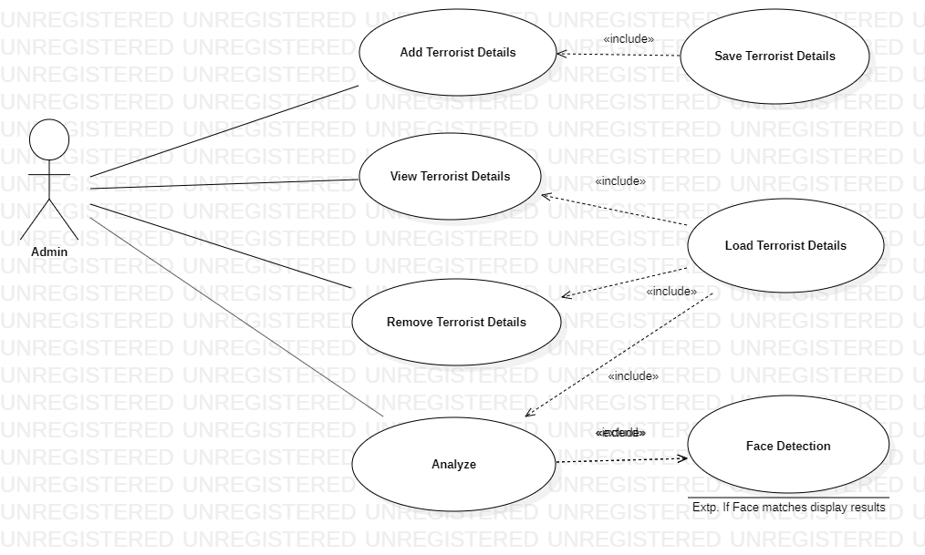

**2. Class Diagrams:**

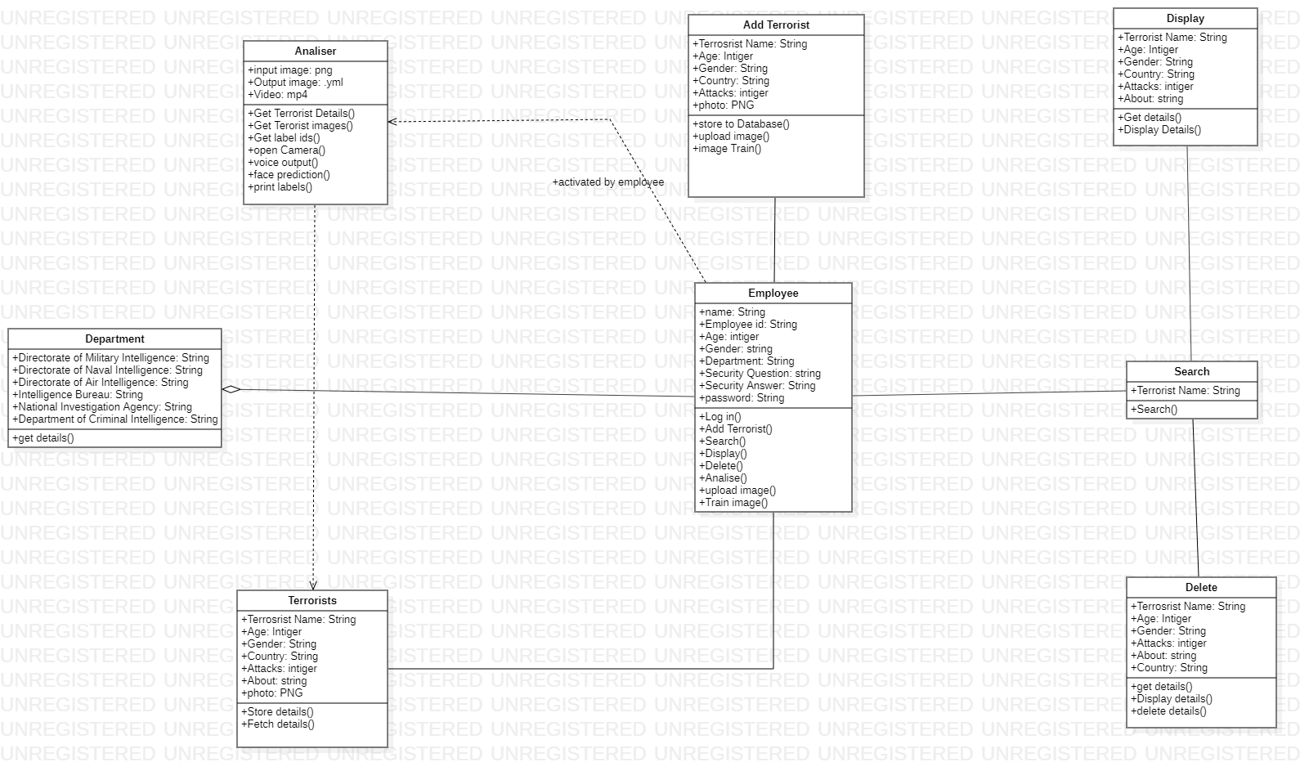

**3. Activity Diagrams:**

**Activity Diagram for Add Terrorist:**

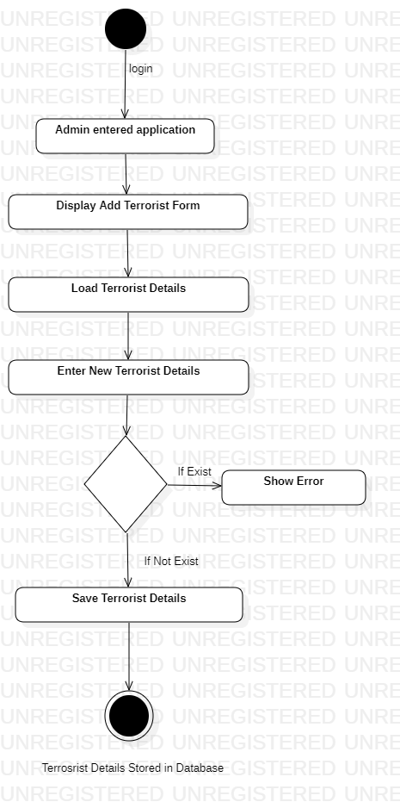

**Activity Diagram for view:**

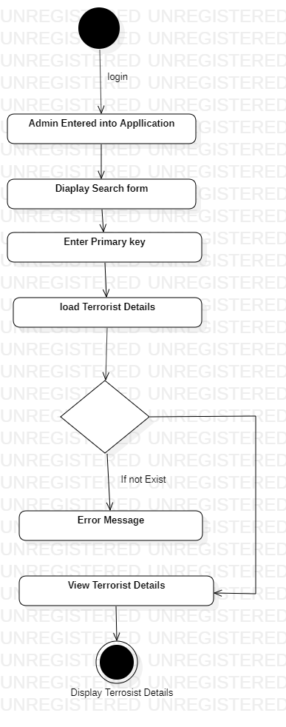

**Activity Diagram for Delete Terrorist:**

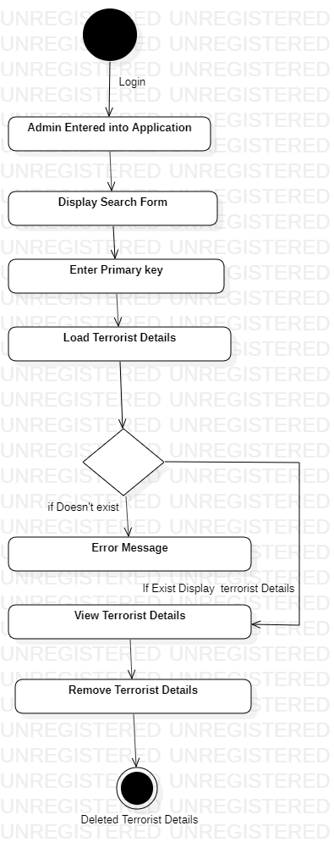

**Activity diagram for Analyze Terrorist:**

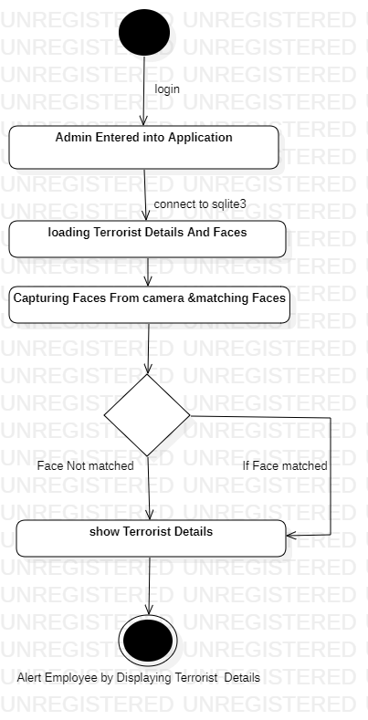

**Sequence Diagrams:**

**1.Sequence Diagram for Add Terrorist Use case**

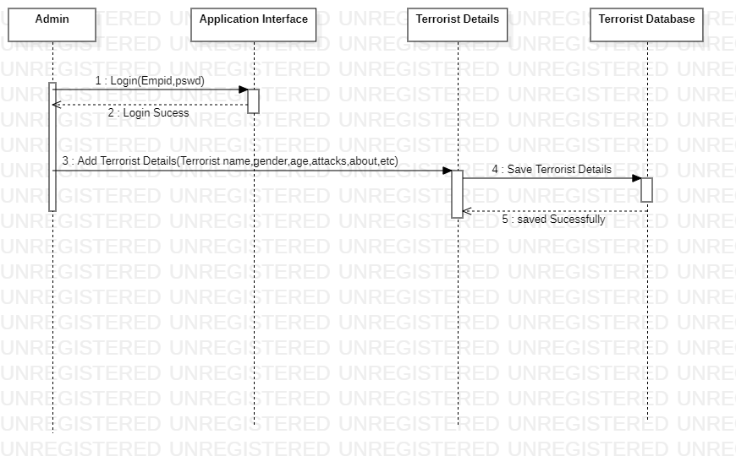

**2. Sequence Diagram for View Terrorist use case:**

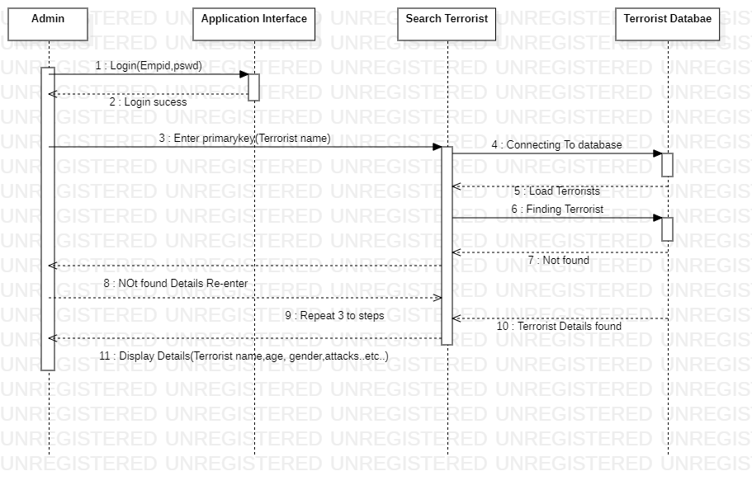

**Sequence Diagram Remove Terrorist use case:**

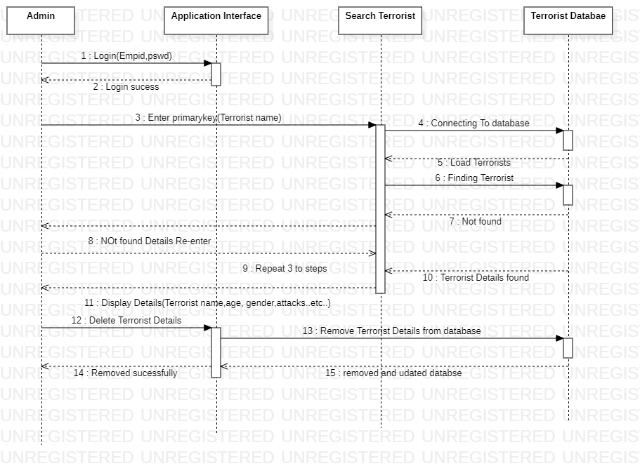

**Sequence Diagram for Analyze Terrorist use case:**

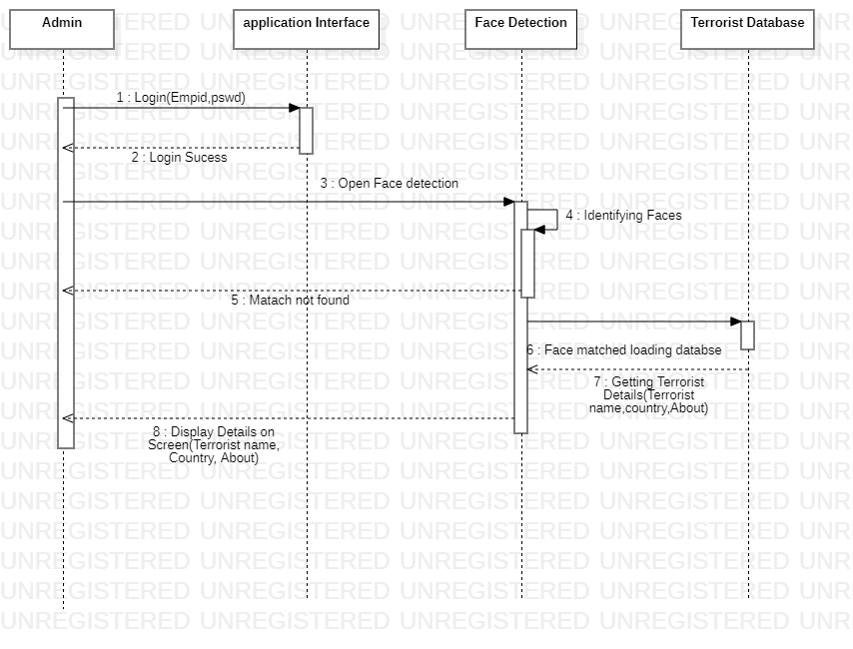

**State Diagrams:**

**State Diagram for Add Terrorist:**

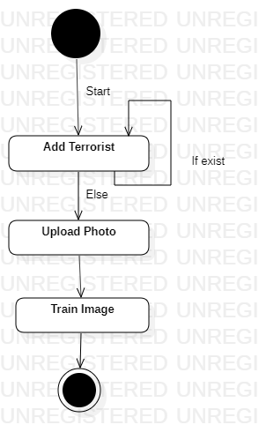

**State Diagram for Display Terrorist:**

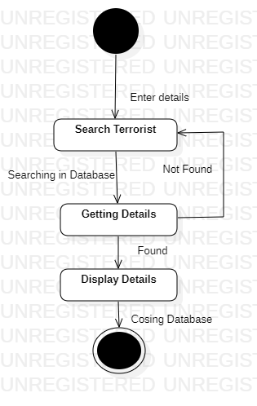

**State Diagram For Delete Terrorist:**

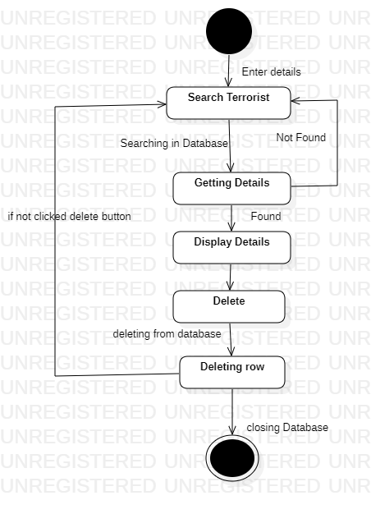

**State Diagram for Analyze Terrorist:**

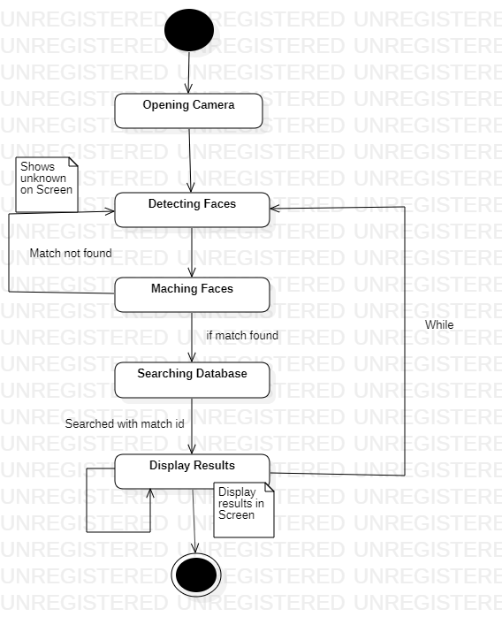

**Interfaces**

**1.Input Forms for Login:**

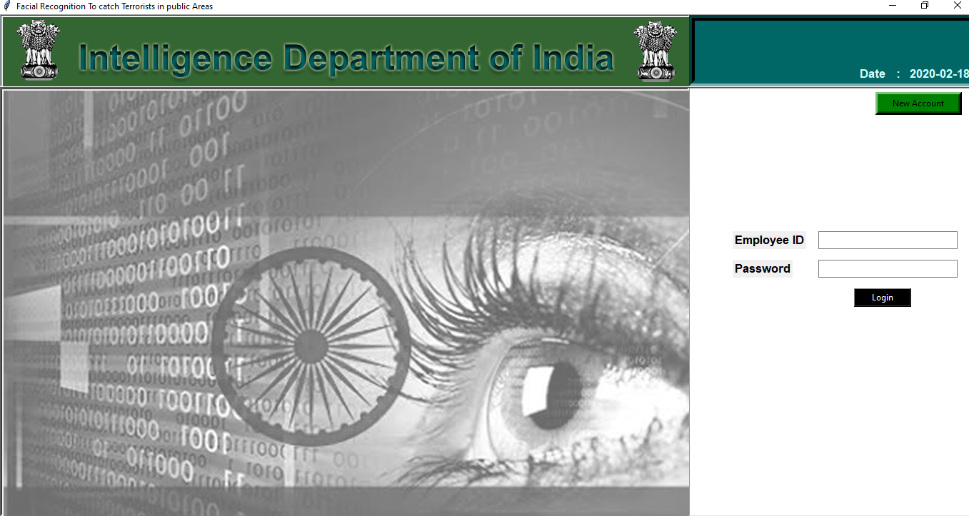

**2.Input form for Employee new Registration:**

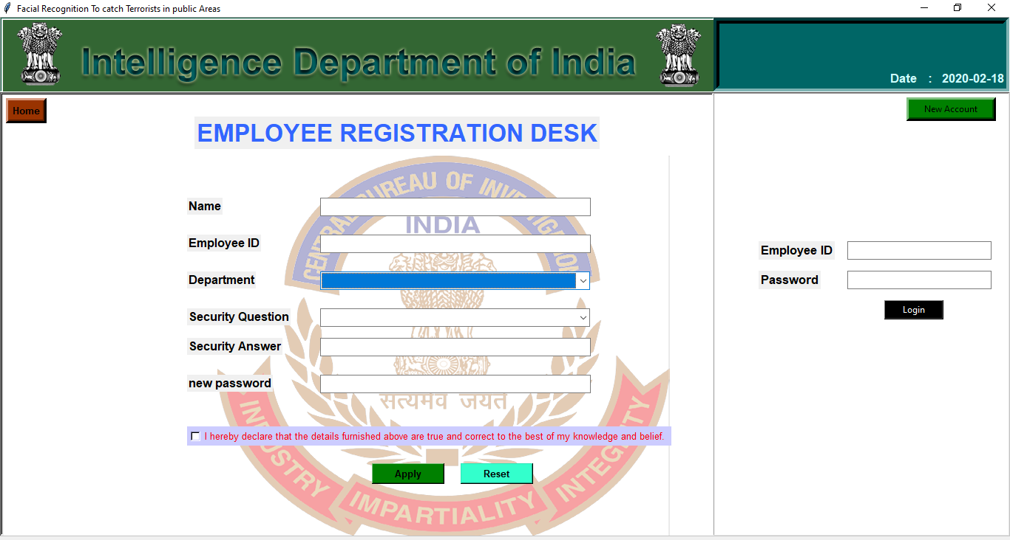

**3.Input form for Add Terrorist:**

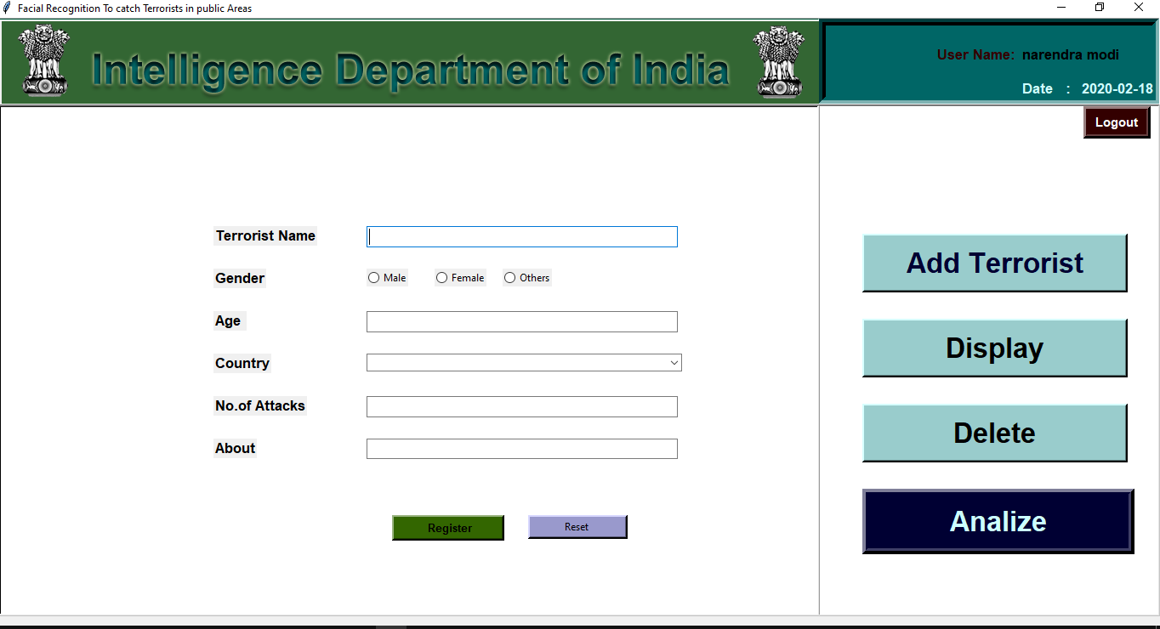

**4. Input Form for Search Terrorist:**

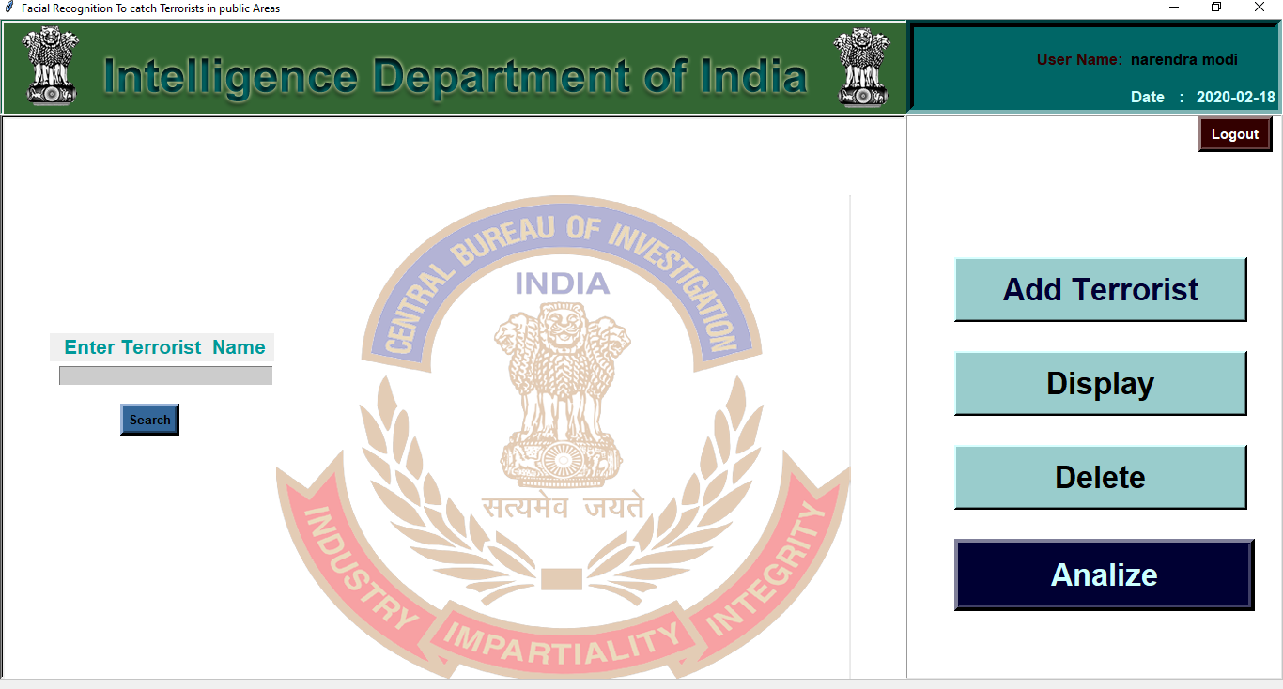

**Database Design**

**Introduction to backend:**

In this application database was designed using sqlite3 database. SQLite is a relational database management system contained in a C library. In contrast to many other database management systems, SQLite is not a client–server database engine. Rather, it is embedded into the end program.

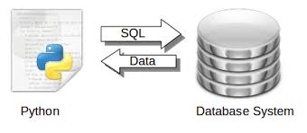

SQLite is ACID-compliant and implements most of the SQL standard, generally following PostgreSQL syntax. However, SQLite uses a dynamically and weakly typed SQL syntax that does not guarantee the domain integrity. This means that one can, for example, insert a string into a column defined as an integer. SQLite will attempt to convert data between formats where appropriate, the string "123" into an integer in this case, but does not guarantee such conversions, and will store the data as-is if such a conversion is not possible.

SQLite is a popular choice as embedded database software for local/client storage in application software such as web browsers. It is arguably the most widely deployed database engine, as it is used today by several widespread browsers, operating systems, and embedded systems (such as mobile phones), among others. SQLite has bindings to many programming languages.

**Sqlite3 Databae browser: :** 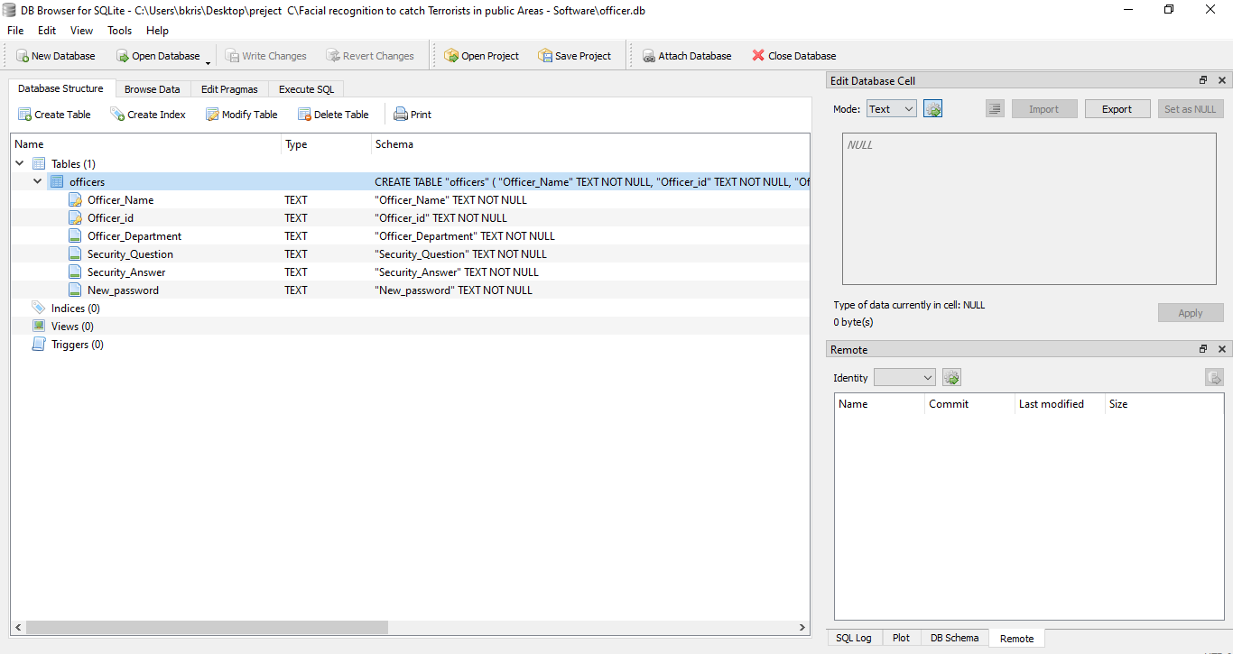

**Normalization Regarding the Project Tables**

Image result for Normalization regarding the project tables. Normalization is a technique for organizing data in a database. It is important that a database is normalized to minimize redundancy (duplicate data) and to ensure only related data is stored in each table. It also prevents any issues stemming from database modifications such as insertions, deletions, and updates

**Data Dictionary:**

**ADD Employee:**

|  |  |  |
| --- | --- | --- |
| column Name | Data type | constraint |
| Officer_Name | String | Not null |
| Officer_id | String | Primary key, Not null |
| Officer_Department | String | Not null |
| Security_Question | String | Not null |
| Security_Answer | String | Not null |
| New_password | String | Not null |

**Add Terrorist:**

|  |  |  |
| --- | --- | --- |
| column Name | Data type | constraint |
| Terrorist_Name | String | Primary key |
| Gender | String |  |
| Age | Intiger |  |
| Country | String |  |
| Attacks_count | Intiger |  |
| About | String |  |

**Table Description**

**Add Employee :**

* Officer_Namewas a String data type this holds only text values otherwise constraint failed and get error storing to employee details while registration.
* Officer_id was and String data type and also this is a primary key for getting identified by the database and connects to the terrorist database.
* Officer_Department was a String data type and also This is not null .This row stores department of the employee.
* Security_Question was also a String data type this is used to store the security question stored in the sqlite3 what employee selected.
* Security_Answer was a String data type which Stores security answer of employee was given.
* New_Password was and String data type which stores different combinations of text what ever user like to store in sqlite table.

**Add Terrorist :**

* Terrorist_Namewas an String Data type and also this was a primary key to retrieve data from the table when ever we want to saw.
* **Gender** was an string data type this stores only text to the table either gender is male ,female, others this will we stored in this row when ever employee entered into this.
* **Age** was an integer data type which stores age of the terrorist.
* **Country** was an string data type which stores country of the terrorist.
* **Attacks_count was an**  integer data type which stores the number of attacks done by the terrorist .
* **About was**  string data type which stores the Details about Terrorist And Their Activities.

**4. Coding**

**Sample Code**

**Database code:**

**Add Employee:**

CREATE TABLE "officers" (

"Officer_Name" TEXT NOT NULL,

"Officer_id" TEXT NOT NULL,

"Officer_Department" TEXT NOT NULL,

"Security_Question" TEXT NOT NULL,

"Security_Answer" TEXT NOT NULL,

"New_password" TEXT NOT NULL,

PRIMARY KEY("Officer_Name","Officer_id")

);

**Add Terrorist :**

CREATE TABLE "terrorists" (

"Terrorist_Name" TEXT NOT NULL UNIQUE,

"Gender" TEXT NOT NULL,

"Age" INTEGER,

"Country" TEXT,

"Attacks_count" INTEGER,

"About" TEXT,

"Photo" BLOB,

PRIMARY KEY("Terrorist_Name")

);

**Application Code(sample)**

**Application Frame Creation code:**

from tkinter import *

import datetime

from tkinter import ttk

from tkinter import messagebox

from tkinter import filedialog

import sqlite3

import cv2

import pyttsx3 as p

import time

import os

from PIL import Image

import facetrain

import faces

engine=p.init() #initiailizing voice command package

date = datetime.datetime.now().date()

con=sqlite3.connect('officer.db') #creating officer database for login empoyees

cur=con.cursor()

terrorists =sqlite3.connect('terrorist.db')

tcur=terrorists.cursor()

con.commit()

class Main(object):

def __init__(self,master):

#initializing all labels to self to master

self.master= master #initializing to master

self.top = Frame(self.master,width=1350,height=100,relief=SUNKEN,borderwidth=1)

self.top.pack(fill=X)

self.bottom = Frame(self.master,bg='#888',width=1350,height=569,relief=SUNKEN,borderwidth=1)

#self.label1 = Label(self.bottom,text='balu').place(x=0,y=0)

self.bottom.pack(fill=X)

#creating top right subframe

self.subframe = Frame(self.top,bg='#006666',width=400,height=100,relief=SUNKEN,borderwidth=8)

self.subframe.pack(fill=X,side=RIGHT)

#creating date

self.datelabel = Label(self.top,text='Date :',font='Areal 13 bold',fg='#CCFFFF',bg='#006666')

self.datelabel.place(x=1200,y=70)

self.dateinput= Label(self.top,text=str(date),font ='Areal 13 bold',fg='#CCFFFF',bg='#006666')

self.dateinput.place(x=1270,y=70)

#creating left frame in top frame

self.subframe0 = Frame(self.top,bg='#009966',width=968,height=100,relief=SUNKEN,borderwidth=1)

self.subframe0.pack(fill=X,side=LEFT)

self.title = Label(self.subframe0,text = 'Intelligence Department of India',

font= 'Britannicbold 25 bold',bg='#009966',fg='#CCFFFF')

self.title.place(x=190,y=20)

self.ib = PhotoImage(file='bagrounds/bgtop.png') #adding image to frame2 sub1

self.label = Label(self.subframe0,image=self.ib).place(x=0,y=0)

#creating subframe1 in bottom frame

self.subframe1 = Frame(self.bottom,bg='white',width=968,height=600,relief=SUNKEN)

self.subframe1.pack(fill=X,side=LEFT)

self.images = PhotoImage(file='bagrounds/bgs.png') #adding image to frame2 sub1

self.label = Label(self.subframe1,image=self.images).place(x=0,y=0)

#creating login page subframe2

self.subframe2 = Frame(self.bottom,bg='white',width=400,height=600,relief=SUNKEN,bd=1)

self.subframe2.pack(fill=X,side=RIGHT)

**Face Recognition code:**

import numpy as np

import cv2

import os

import pickle

import pyttsx3 as p

import sqlite3

import time

import facetrain

#facetrains= facetrain.train()

engine=p.init() #voice information module initilalised.....

def faces():

engine.say("Analiser initiated \n please wait connectiong to database \n if you want to exit analizer press q in keyboard ")

engine.runAndWait()

face_cascade=cv2.CascadeClassifier('cascades/haarcascade_frontalface_alt2.xml')

eye_cascade=cv2.CascadeClassifier('cascades/haarcascade_eye.xml')

smile_cascade=cv2.CascadeClassifier('cascades/haarcascade_smile.xml')

recogniser = cv2.face.LBPHFaceRecognizer_create()

recogniser.read('trainer.yml')

#loading label names...

labels={'id':'1'}

with open('labels.pickle','rb') as file:

org_labels=pickle.load(file)

labels={v:k for k,v in org_labels.items()}

capture=cv2.VideoCapture(2)

while(True):

#reading the video frames...

ret,frame=capture.read()

gray=cv2.cvtColor(frame,cv2.COLOR_BGR2GRAY)

faces=face_cascade.detectMultiScale(gray,scaleFactor=1.3,minNeighbors=5)

for(x,y,w,h) in faces:

print(x,y,w,h)

roi_gray=gray[y:y+h,x:x+w]#[ycord start x,ycord end]

roi_color=frame[y:y+h,x:x+w]#[ycord start x,ycord end]

#recognising now

id_,conf =recogniser.predict(roi_gray)

if conf>=45 and conf<=85:

print(id_)

print(conf)

print(labels[id_])

font=cv2.FONT_HERSHEY_SIMPLEX

name=labels[id_]

color = (0,0,0)

stroke= 2

#accessing database names now

terrorists =sqlite3.connect('terrorist.db')

tcur=terrorists.cursor()

display_ter=tcur.execute('SELECT * FROM terrorists WHERE Terrorist_Name=?',(name,))

show=(display_ter.fetchall())

try:

tname = show[0][0]

tcountry = show[0][3]

tabout = show[0][5]

cv2.putText(frame,('Name :'),(10,380),font,1,color,stroke,cv2.LINE_AA)

cv2.putText(frame,('Country :'),(10,420),font,1,color,stroke,cv2.LINE_AA)

cv2.putText(frame,('Status :'),(10,460),font,1,color,stroke,cv2.LINE_AA)

#inputs

color2=(204,102,0)

color3=(0, 0, 255)

cv2.putText(frame,name,(200,380),font,1,color2,stroke,cv2.LINE_AA)

cv2.putText(frame,tcountry,(200,420),font,1,color2,stroke,cv2.LINE_AA)

cv2.putText(frame,tabout,(200,460),font,1,color3,stroke,cv2.LINE_AA)

#engine.say(" terrorist recognised ")

#engine.runAndWait()

except:

un='unknown'

cv2.putText(frame,un,(y,x-50),font,1,color,stroke,cv2.LINE_AA)

if conf<45 and conf >=100:

un='unknown'

cv2.putText(frame,un,(y,x-50),font,1,color,stroke,cv2.LINE_AA)

img_item=("face data\my image.png")

cv2.imwrite(img_item,roi_color)

#creating the raectangle to the face..

color=(255,0,0)#BGR O-255

stroke=2

endcord_x=x+w #width of rectangle

endcord_y=y+h #height of rectagle

cv2.rectangle(frame,(x,y),(endcord_x,endcord_y),color,stroke)

#creating smile cascade

smile=eye_cascade.detectMultiScale(roi_gray)

for(ex,ey,ew,eh) in smile:

cv2.rectangle(roi_color,(ex,ey),(ex+ew,ey+eh),(0,255,0),1)

#displaying the results frame.....

cv2.namedWindow('Analizing', cv2.WINDOW_NORMAL)

cv2.resizeWindow('Analizing', 1368, 720)

cv2.imshow('Analizing',frame) #showing the frame...

if cv2.waitKey(20)& 0xFF==ord('q'):

break

#when everythinng done, relese capture

capture.release()

cv2.destroyAllWindows()

5. Testing

**Introduction to Testing**

Software testing is a process, to evaluate the functionality of a software application with an intent to find whether the developed software met the specified requirements or not and to identify the defects to ensure that the product is defect free in order to produce the quality product.

**Software Testing Types:**

Manual Testing: Manual testing is the process of testing software by hand to learn more about it, to find what is and isn’t working. This usually includes verifying all the features specified in requirements documents, but often also includes the testers trying the software with the perspective of their end user’s in mind. Manual test plans vary from fully scripted test cases, giving testers detailed steps and expected results, through to high-level guides that steer exploratory testing sessions. There are lots of sophisticated tools on the market to help with manual testing, but if you want a simple and flexible place to start, take a look at Test pad.

Automation Testing: Automation testing is the process of testing the software using an automation tool to find the defects. In this process, testers execute the test scripts and generate the test results automatically by using automation tools. Some of the famous automation testing tools for functional testing are QTP/UFT and Selenium.

**Testing Methods**:

* + - Static Testing
    - Dynamic Testing

**Static Testing**:

It is also known as Verification in Software Testing. Verification is a static method of checking documents and files. Verification is the process, to ensure that whether we are building the product right i.e., to verify the requirements which we have and to verify whether we are developing the product accordingly or not.

**Dynamic Testing**:

It is also known as Validation in Software Testing. Validation is a dynamic process of testing the real product. Validation is the process, whether we are building the right product i.e., to validate the product which we have developed is right or not.

**Testing Approaches:**

There are three types of software testing approaches.

White Box Testing

Black Box Testing

Grey Box Testing

**White Box Testing**:

It is also called as Glass Box, Clear Box, Structural Testing. White Box Testing is based on applications internal code structure. In white-box testing, an internal perspective of the system, as well as programming skills, are used to design test cases. This testing is usually done at the unit level.

**Black Box Testing**:

It is also called as Behavioral/Specification-Based/Input-Output Testing. Black Box Testing is a software testing method in which testers evaluate the functionality of the software under test without looking at the internal code structure.

**Grey Box Testing:**

Grey box is the combination of both White Box and Black Box Testing. The tester who works on this type of testing needs to have access to design documents. This helps to create better test cases in this process.

No matter whether you are a Black box, White box or Grey box tester. Success of a project due to testing in Software Engineering has a huge role.

**Methodologies:**

At SDEI, 3 levels of software testing is done at various SDLC phases

**Unit testing:** in which each unit (basic component) of the software is tested to verify that the detailed design for the unit has been correctly implemented

**Integration testing**: in which progressively larger groups of tested software components corresponding to elements of the architectural design are integrated and tested until the software works as a whole.

**System testing**: in which the software is integrated to the overall product and tested to show that all requirements are met .A further level of testing is also done, in accordance with requirements:

**Acceptance testing**: upon which the acceptance of the complete software is based. The clients often do this.

**Regression testing**: is used to refer the repetition of the earlier successful tests to ensure that changes made in the software have not introduced new bugs/side effects.

**Test Cases**

**Employee / admin Test Case :**

|  |  |  |  |  |  |  |
| --- | --- | --- | --- | --- | --- | --- |
| Test case ID | Test Scenario | Test Steps | Test Data | Expected Results | Actual Results | Pass/Fail |
| REG1 | Register Employee for log into terrorist database | 1.click on New Account.  2.Enter details what form asking  3.click submit. | Name=balu,  Empid = 1  Department=intelligence baure ,  Security question= your fav. Book  Security answer = maths,  New password = 123 | Registered Successfully | As expected | pass |
| REG2 | Login Employee | 1.enter employee id  2.enter password | Empid = 1,pswrd = 123 | Employee Logged into application | As expected | pass |

**Add Terrorist Test Case:**

|  |  |  |  |  |  |  |
| --- | --- | --- | --- | --- | --- | --- |
| Test case ID | Test Scenario | Test Steps | Test Data | Expected Results | Actual Results | Pass/Fail |
| TER1 | Add terrorist | 1.click add Terrorist button  2.enter details  3.click submit  4.click upload photo  5.upload photo  6.click train image | Terrorist name = bill laden,  Age=55  Gender=male  Attacks=3  Country= Pakistan  About= he was a most wanted terrorist | Terrorist  Added to database | AS expected | pass |

**View Terrorist Test Case:**

|  |  |  |  |  |  |  |
| --- | --- | --- | --- | --- | --- | --- |
| Test case ID | Test Scenario | Test Steps | Test Data | Expected Results | Actual Results | Pass/Fail |
| TER2 | View Terrorist | 1.click on Display Terrorist.  2.enter terrorist name  3.click on submit | Terrorist name = bill laden, | Shows Terrorist Details in screen | AS expected | pass |

|  |  |  |  |  |  |  |
| --- | --- | --- | --- | --- | --- | --- |
| Test case ID | Test Scenario | Test Steps | Test Data | Expected Results | Actual Results | Pass/Fail |
| TER3 | View Terrorist | 1.click on Display Terrorist.  2.enter terrorist name  3.click on submit  4.click on delete | Terrorist name = bill laden, | Shows Terrorist Details in screen if click delete  Terrorist details deleted form database successfully. | AS expected | pass |

**Remove Terrorist Test Case:**

|  |  |  |  |  |  |  |
| --- | --- | --- | --- | --- | --- | --- |
| Test case ID | Test Scenario | Test Steps | Test Data | Expected Results | Actual Results | Pass/Fail |
| TER4 | AnalizeTerrorist | 1.click on Analyze button | Loading data form root folder automatically | Shows Terrorist Details on screen if captured images was matched to terrorist faces and inform to employee | AS expected | pass |

**Analyze Terrorist Test Case:**

**6. Screenshots**

**Screenshots**

**Login page:**

**Login** page was designed with Frames in python GUI . if you want to access this application you must have an employee-id and password .if must verified from sqlite3 in officers table.

1.login page for enter employee id and password.

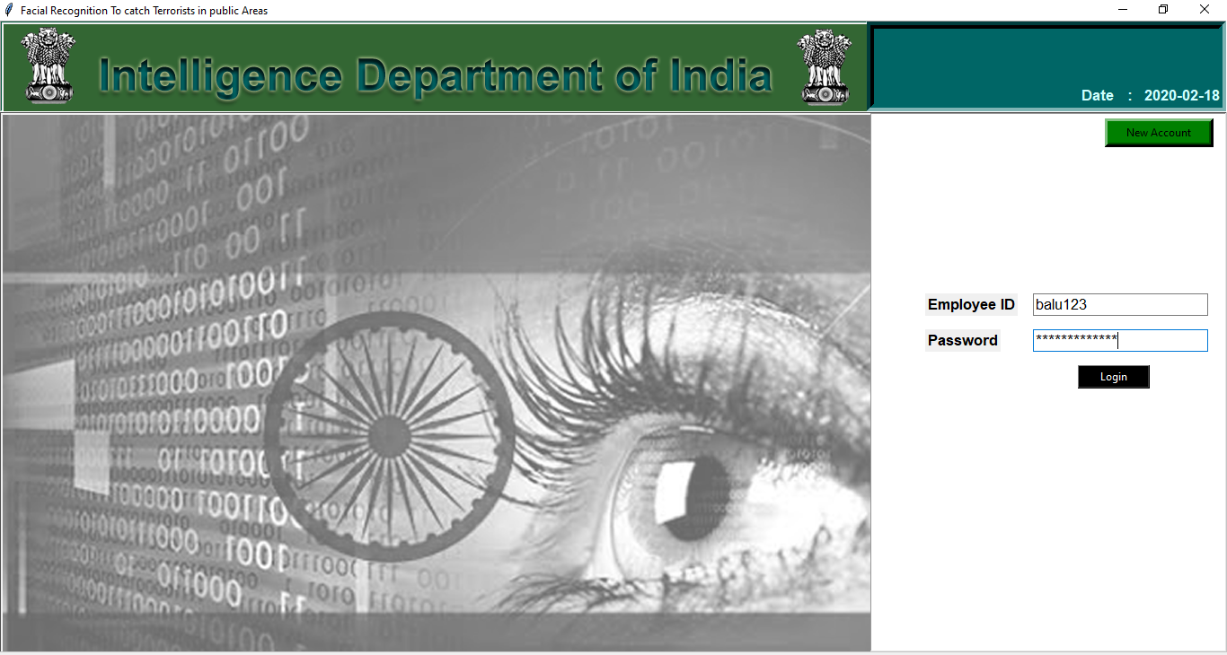

2. If not correct

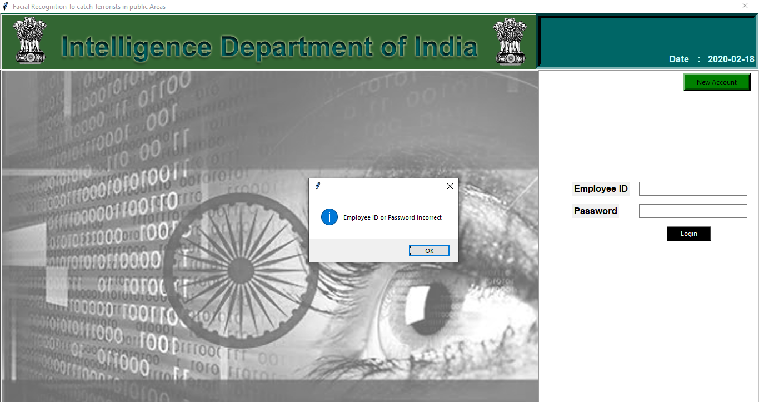

**New Account :**

1. Creating new employee Account .



2.enter Details correctly

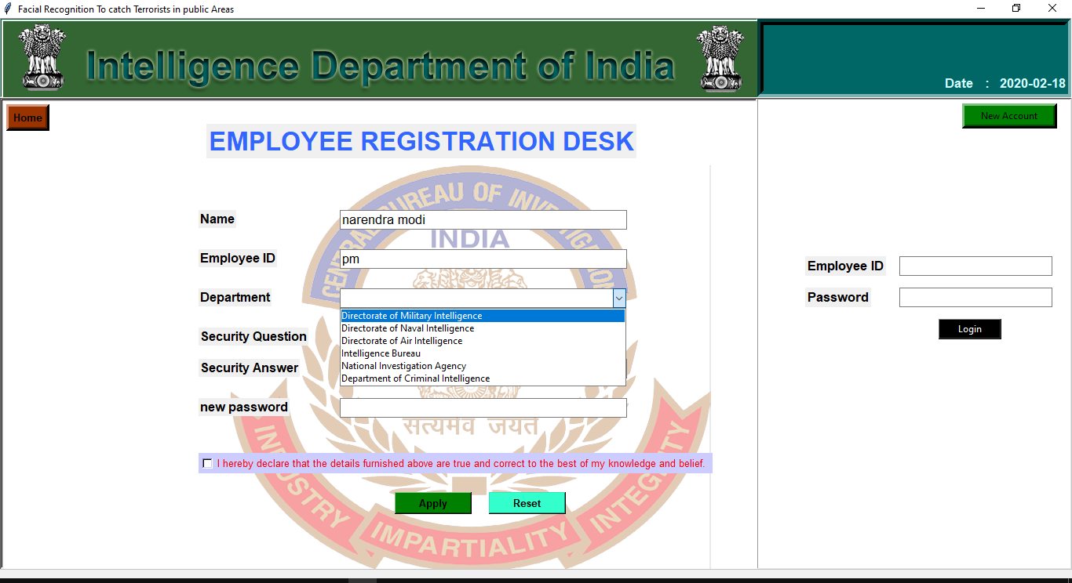

1. Fill complete details.

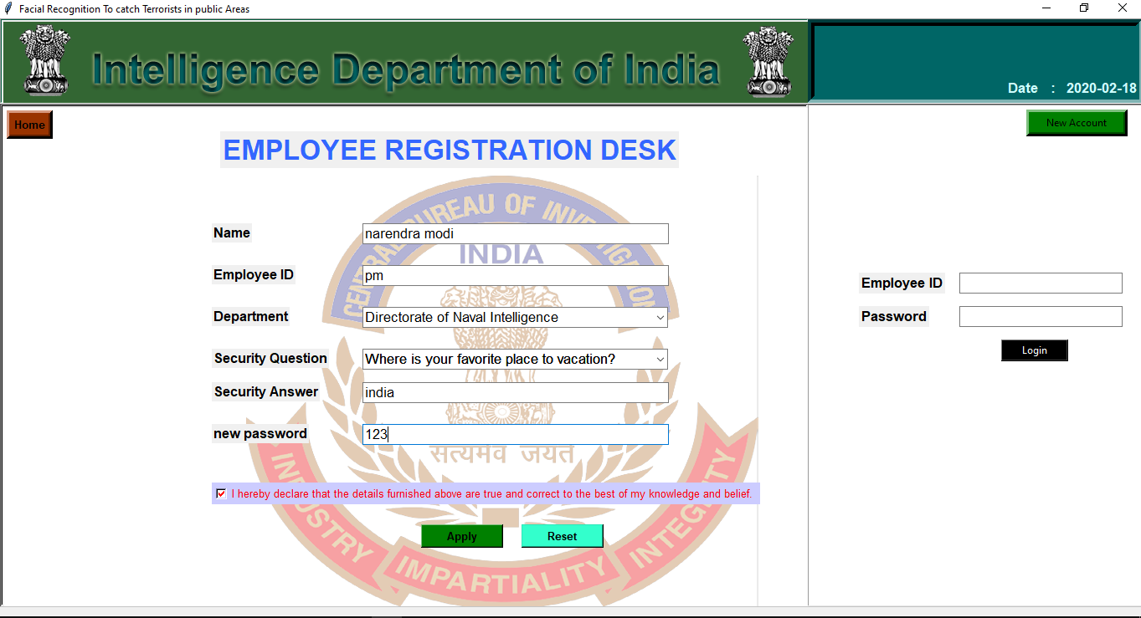

4.click **Agree**

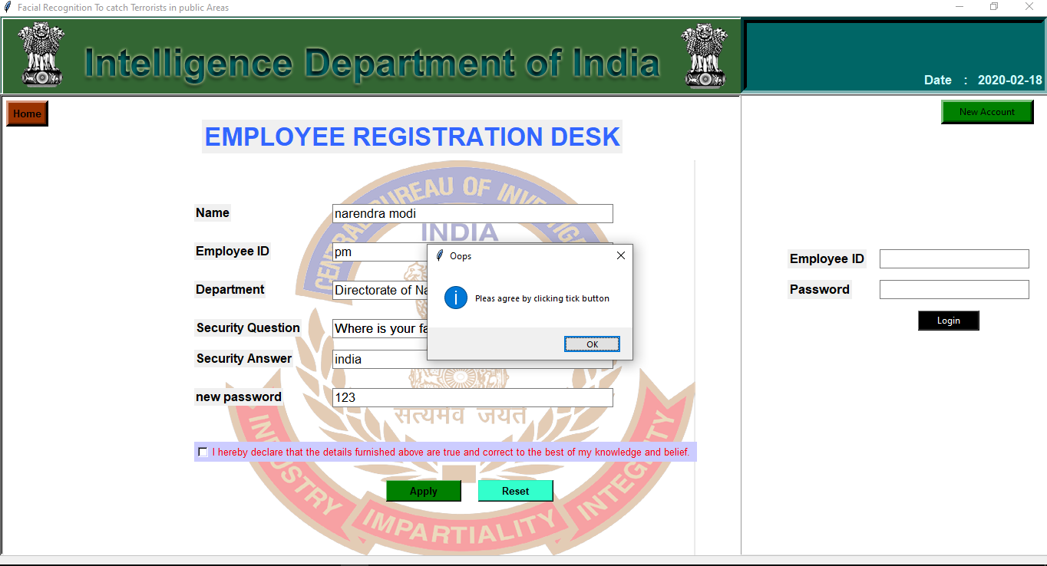

4.Account Created and will be activated soon message

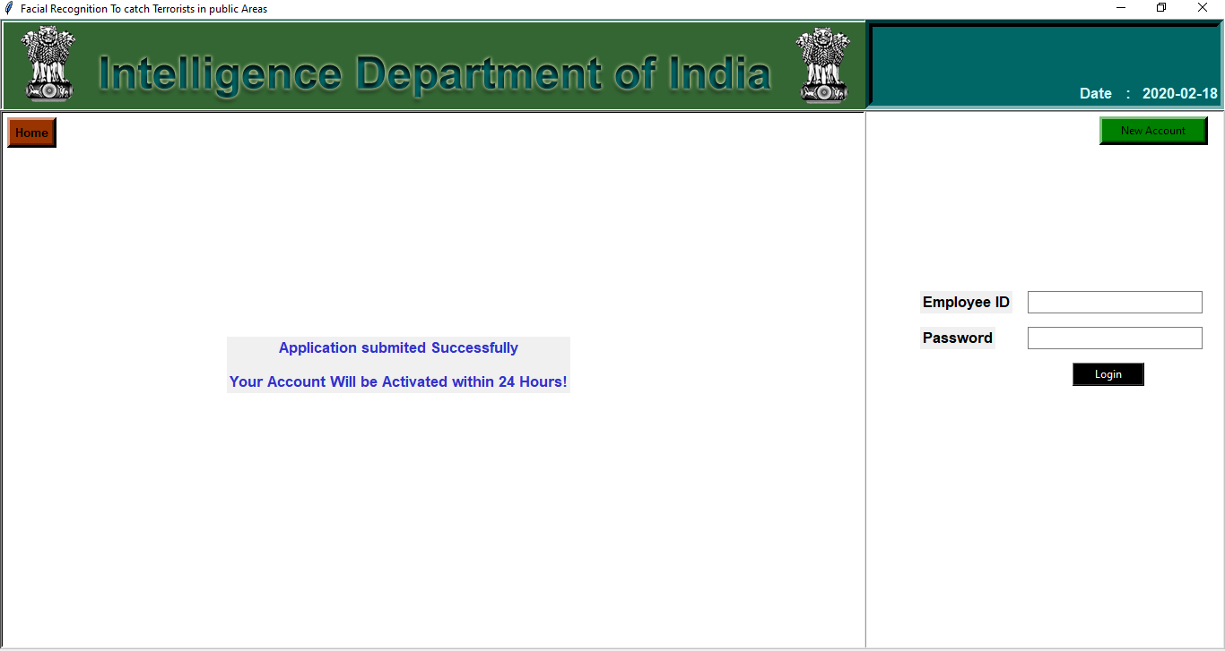

5.If you **click HOME** button .

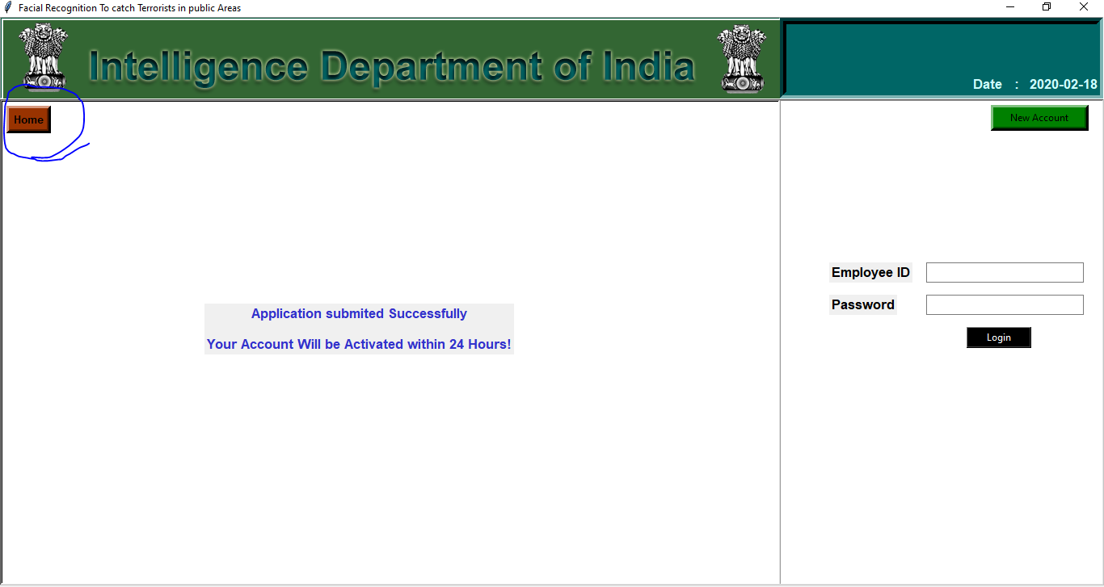

6.Login with ID.

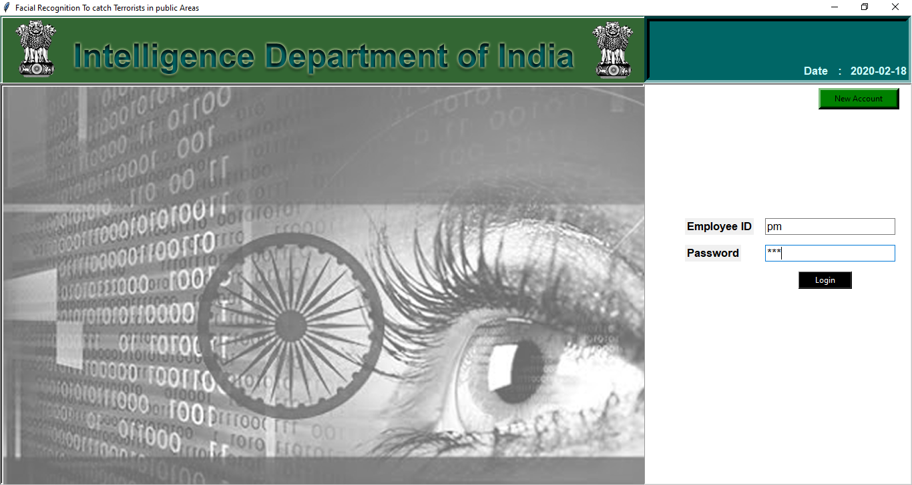

7.After login showing Main window.

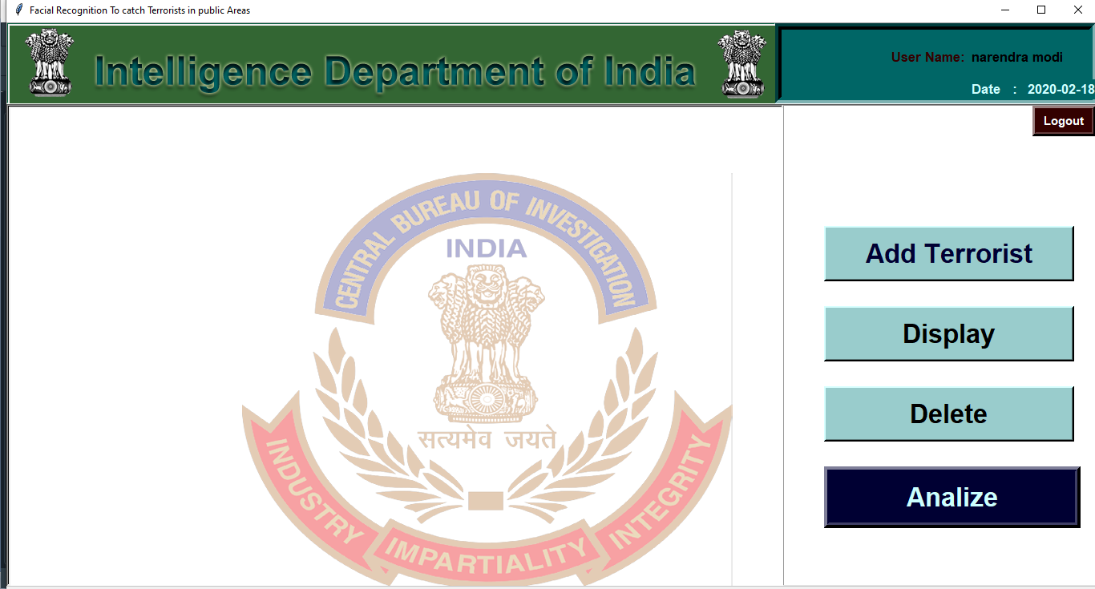

**Add Terrorist :**

**1.**Adding Terrorist please fill detaisl below.



2.filling details

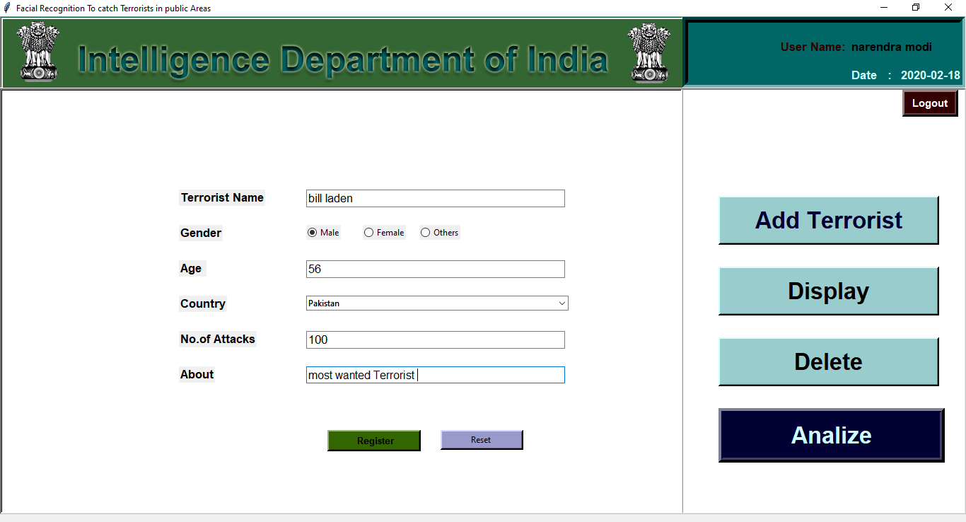

3.Upload an image.

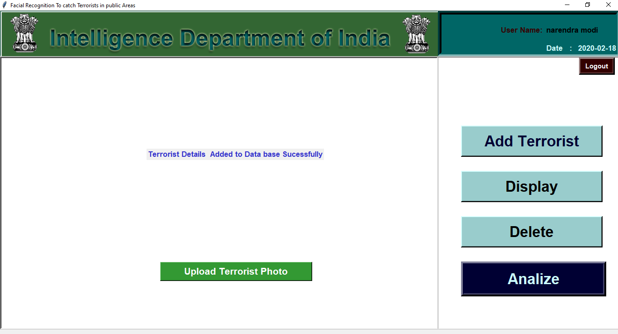

4.select image from folder.

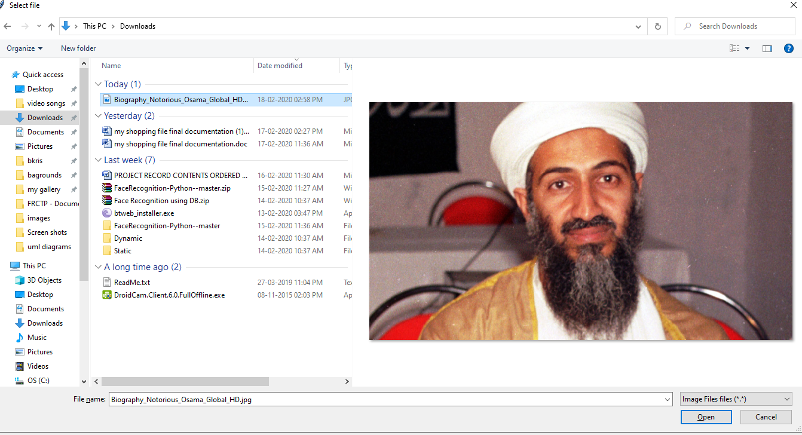

5.image uploaded to root folder.

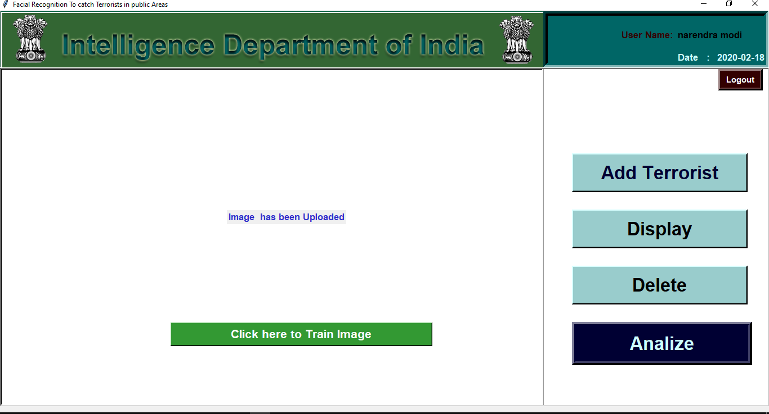

Floder.. images

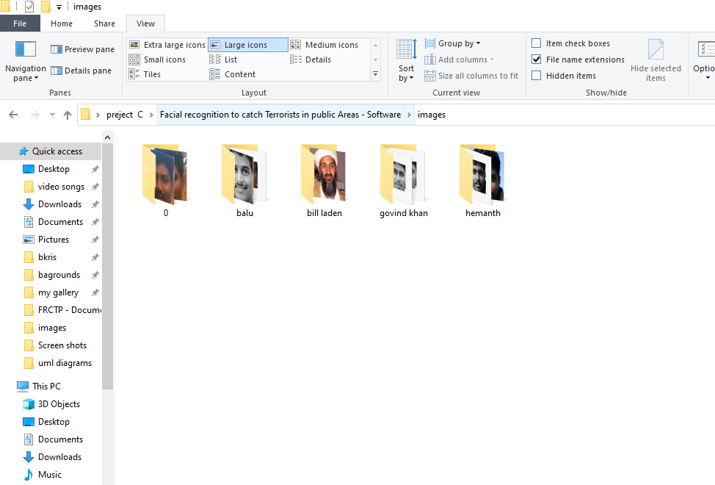

6.training image in machine learning for future predictions.

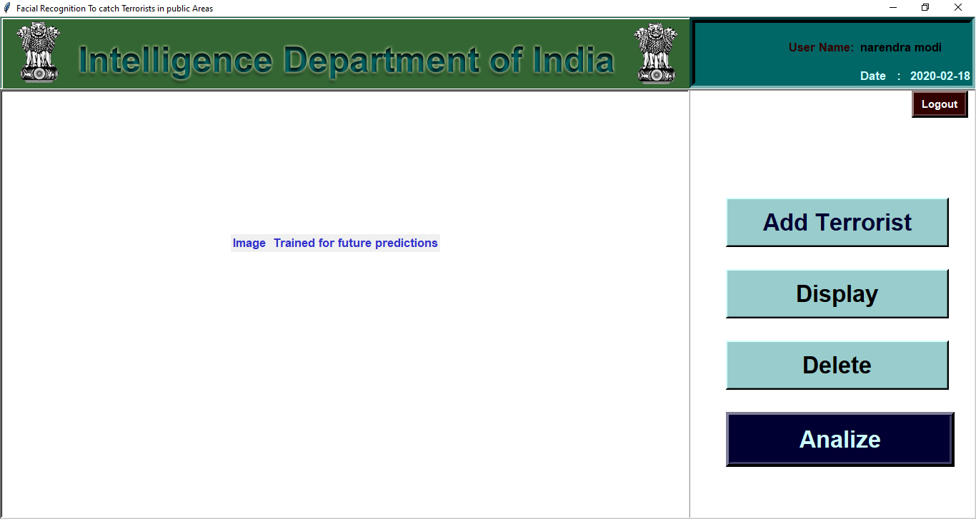

7.trained labels created with YMLfile in root folder.

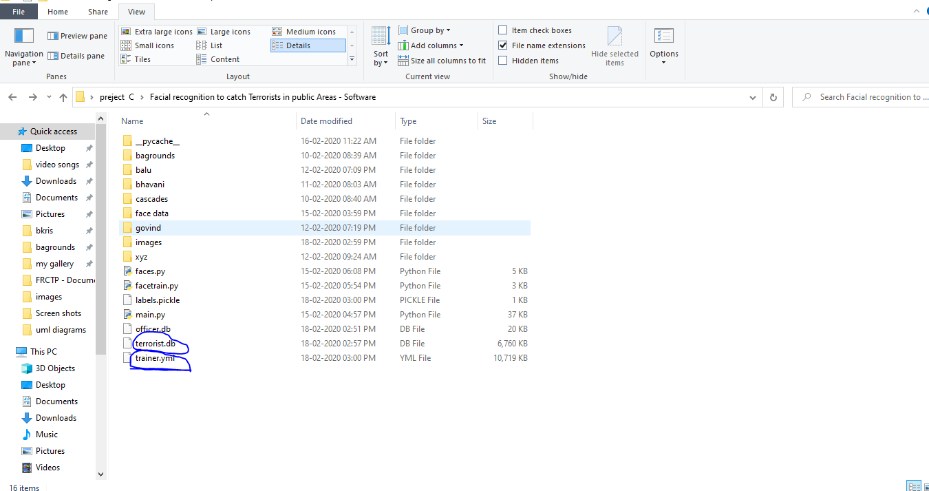

**Display Terrorist :**

1.search terrorist name.



2.showing details if exist.

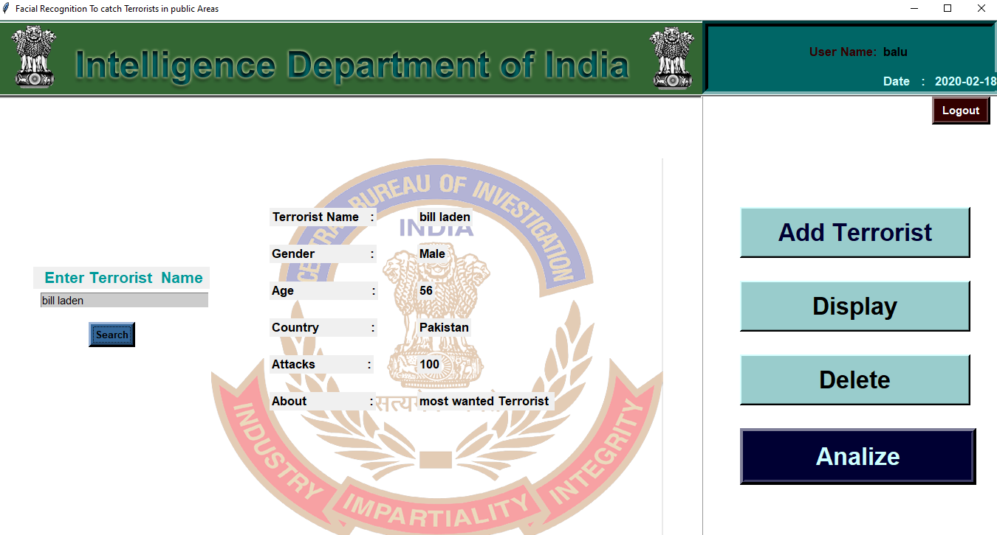

3.if doesn’t exist show error.

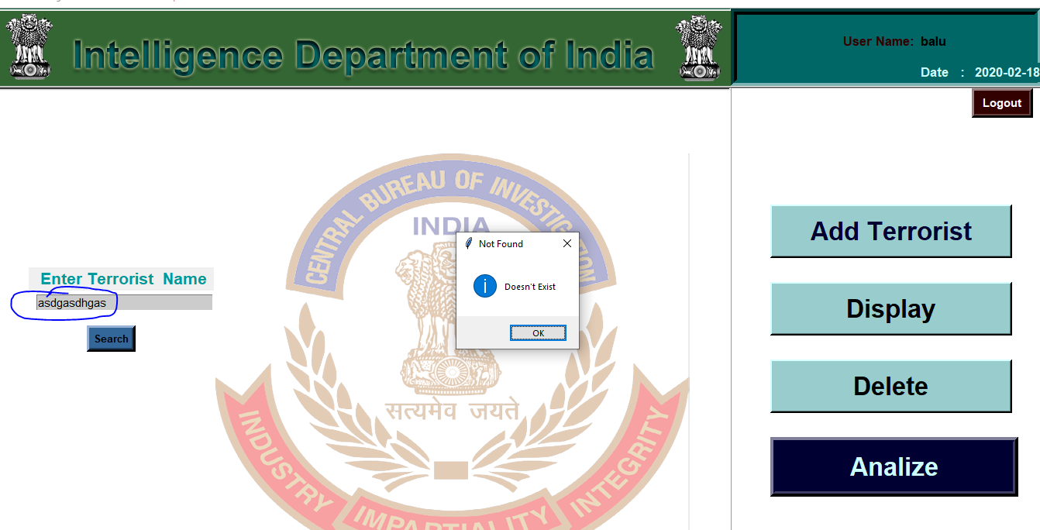

**Delete Terrorist :**

1.search terrorist and showing details.

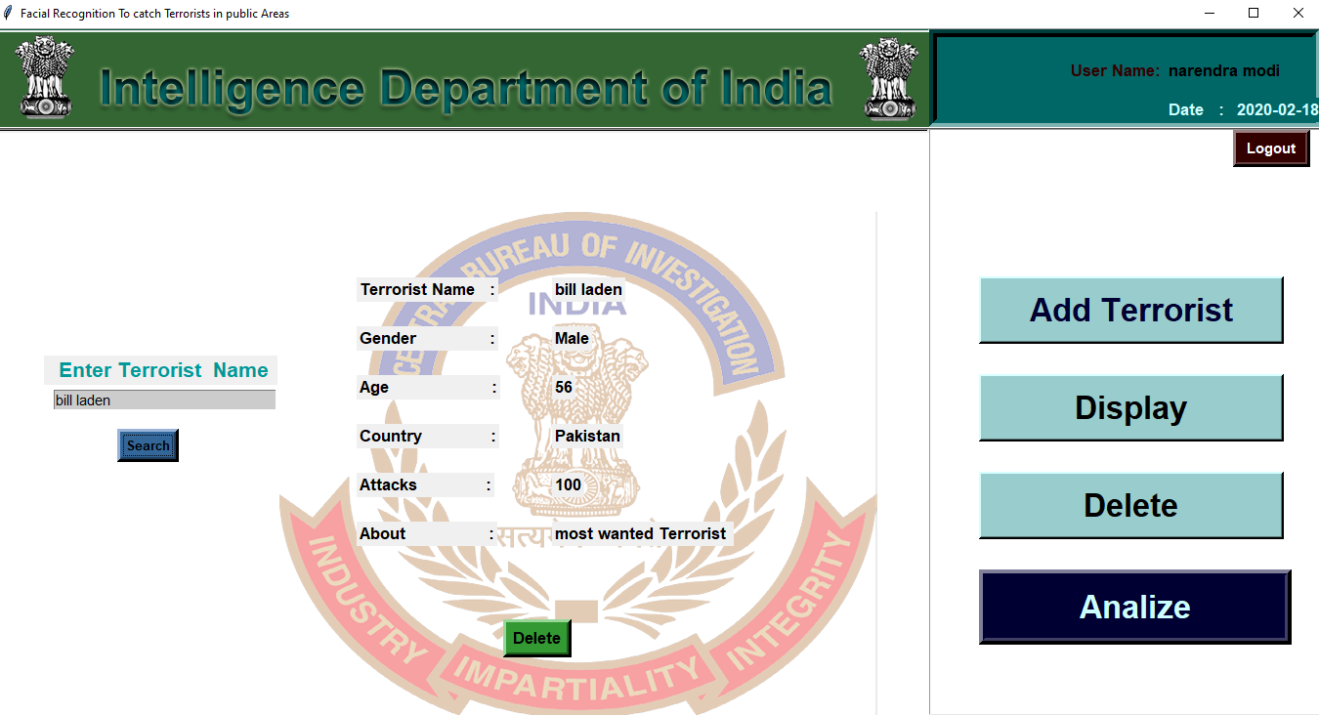

2.click delete button all row was wiped from table.

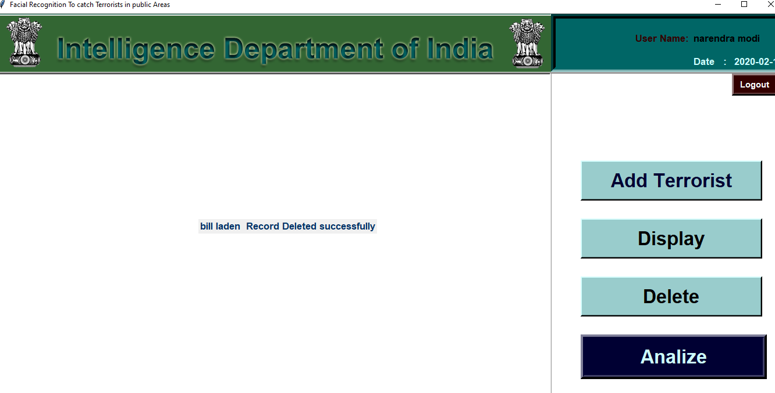

**Analize :**

1.click analyze button its opens camera and connected data base and detecting faces and showing resultts.

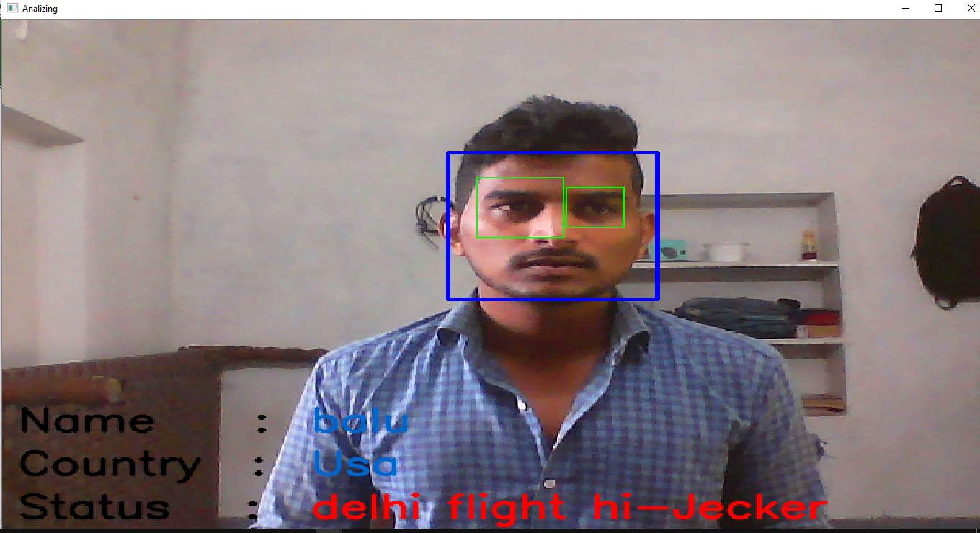

2.else its shows unknown identified person doesn’t exist.

Press ‘**Q’** to exit analyzer.

3.if I click Logout.

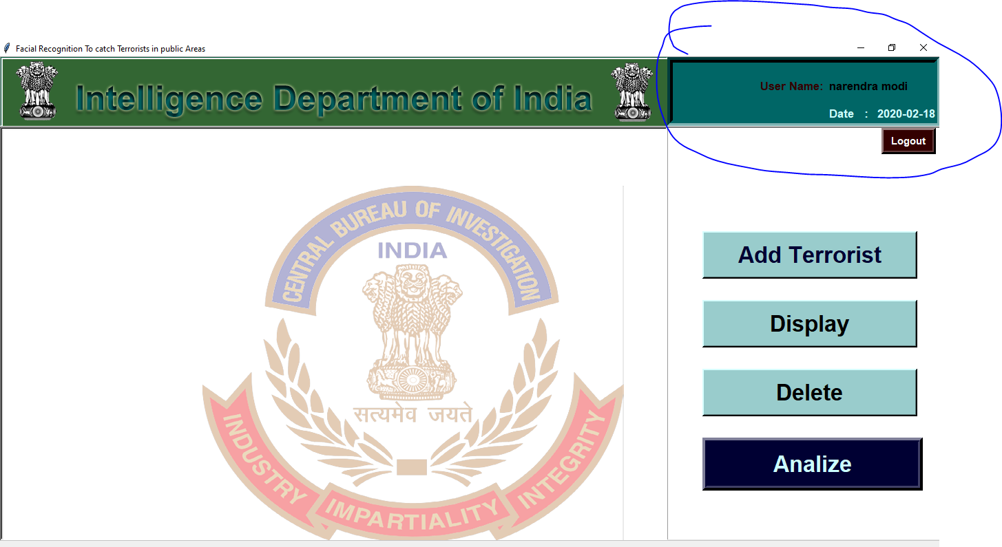

4. Log out all details wiped on screen shows fresh screen.

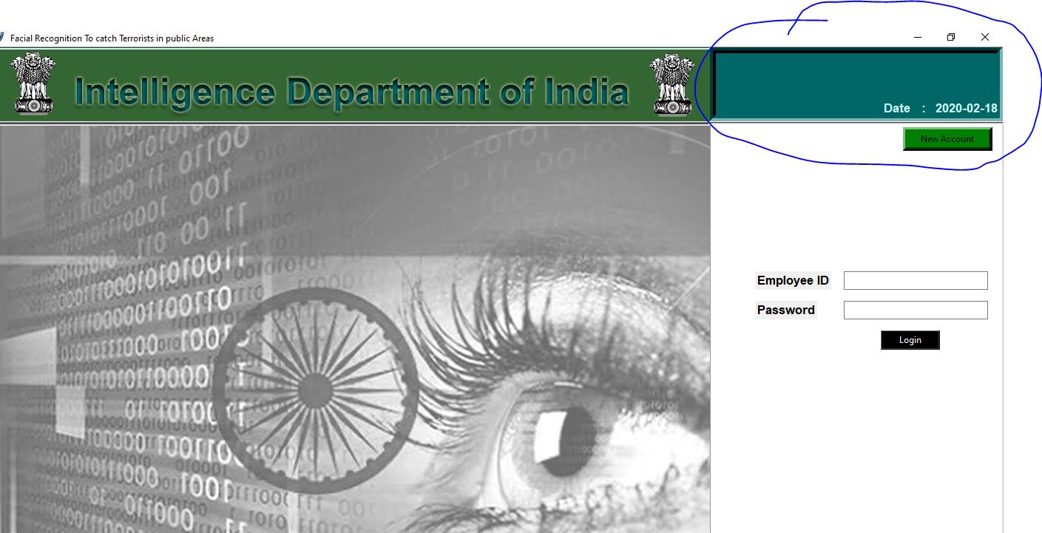

**7. Conclusion**

**Conclusion**

Face Recognition Working :

Here we are Successfully done facial recognition using opencv to recognize faces terrorist faces what we are given as input to this system. This was actually designed for Indian intelligence Department to save thousands of lives in real world and real situations. This project really helps to Indian intelligence department to get make sure result about terrorist or criminals arrival into India anyway.

**GOALS:**

* Finding missing Terrorists
* Alert Defense people before any Accused person arrival
* Get alert before something bad happen to people.
* Easy to use this application.
* Reducing work to search people .
* User friendly screens to enter the data
* Portable and flexible for further enhancement
* Easy retrieval of information
* Reduced errors due to human intervention

**Future Scope for This project:**

Future Scope For this project was more useful because this is only present this is only analyzing face to detect their faces are exist or not, but in future this project will gone to another level because this needs more algorithms to work more efficiently and also works on night time and continuous tracing terrorist activities and continuous informing to defense department each and every second. this all work done with laths of cameras at a single time. this project needs an **AI** program and need more data and algorithms .preset This application was only limited to recognizing faces.

**----------------------------Thank You-------------------------**

**8. Bibiliography**

**Bibliography**

[1] Face Detection & Face Recognition Using Open Computer Vision Classifiers.

https://www.researchgate.net/publication/318900718_Face_Detection_Face_Recognition_Using_Open_Computer_Vision_Classifies

[2] <https://www.superdatascience.com/blogs/opencv-face-detection>

[3] <https://www.superdatascience.com/blogs/opencv-face-recognition>

[4] Face Detection and Recognition using OpenCV, Article, Published by ShervinEmami, 2010.

<http://shervinemami.info/faceRecognition.html>

[5] Seeing with OpenCV, Article, Published by Robin Hewitt, 2010

<http://www.cognotics.com/opencv/servo_2007_series/part_1/index.html>

[6] OpenCV Homepage

<http://opencv.willowgarage.com>

[7] Comparison of Face Recognition Algorithms Using Opencv for Attendance System by SudhaNarang, Kriti Jain, MeghaSaxena, AashnaArora

<http://www.ijsrp.org/research-paper-0218.php?rp=P747200>

[8] Python GUI programming language :

<https://www.udemy.com/course/python-tkinter-masterclass/learn/lecture/13552348?start=870#questions>

[9] Sqlite3 <https://www.sqlite.org/doclist.html>